**TABLE OF CONTENTS**

|  |  |  |
| --- | --- | --- |
| **No.** | **Title** | **Page No.** |
| **1** | **Project Profile** |  |
|  | 1.1 Definition |  |
|  | 1.2 Scope |  |
|  | 1.3 Objective |  |
| **2** | **System Analysis And Specification** |  |
|  | 2.1 Existing System |  |
|  | 2.2 Limitation Of Existing System |  |
|  | 2.3 Feasibility Study |  |
|  | 2.4 Need Of New System |  |
|  | 2.5 Font End & Back End Tools |  |
| **3** | **System Requirement Specification** |  |
|  | 3.1 Proposed System And Advantage |  |
|  | 3.2 Development Strategy Model |  |
| **4** | **System Design** |  |
|  | 4.1 Data Flow Diagram |  |
|  | 4.2 E-R Diagram |  |
|  | 4.3 Class Diagram |  |
|  | 4.4 Use Case Diagram |  |
|  | 4.5 Sequence Diagram |  |
|  | 4.6 Activity Diagram |  |
|  | 4.7 Data Dictionary (Database) |  |
| **5** | **Screen Design** |  |
|  | 5.1 Input Screen |  |
|  | 5.2 Output Screen |  |
|  | 5.3 Report Design |  |
| **6** | **Coding** |  |
| **7** | **Testing (Manual Test Cases and Test Data)** |  |
|  | 7.1 Manual Testing |  |
|  | 7.2 Test Cases |  |
| **8** | **Enhancements** |  |
|  | 8.1 Advantage Of Your Project |  |
|  | 8.2 Limitation Of Your Project |  |
|  | 8.3 Feature Scope |  |
| **9** | **References** |  |

1

PROJECT PROFILE

* 1. **Project Definition**
  2. **Project Scope**
  3. **Project Objective**

|  |  |  |
| --- | --- | --- |
| Project Profile | | |
|  | **Enrollment No.** | 03052001105  03052001105  03052001102 |
|  | **Student Name** | Timbaliya Rahul  Mihir Vaddoriya  Manish Parmar |
|  | **Project Title** | **India_Tour** |
|  | **Project Type** | Web Application |
|  | **Tools & Technology** | HTML,CSS,  JAVA-SCRIPT  PYTHON-DJANGO,  MYSQL |
|  | **Front – End** | DJANGO HTML CSS  JAVA SCRIP |
|  | **Back – End** | MYSQL,SQLLITE |
|  | **Team Member** | 3 |

**1.1 Project Definition :-**

* India_Tour System is a web-based technology that manages tour package and customer to easily book and find information about place
* India_Tour system is a web-based system which help tourist to see available Package in company and book that package online to save time and money
* Administration can store the data of package . The System also keeps the user book info**.**
* This project uses Django and MYSQL,SQLite databases, and it has a module that is admin. All possible features such as validation, validation, security, etc., are considered.
* The proposed system influences or interacts with Tourist That can find any online service to book its package.
* This project also includes system testing and validation, which ensures that your System is error-free and working as expected.
  1. **Project Scope**

A . **Hardware Specification**

* Intel-core-i3/Intel-core-i5 and Higher Prosessor
* 512 Mb Ram
* 1 GB Free Hard-Drive Space

**A . Software Specification**

* PHP (Font-end)
* HTML
* JavaScript
* MS Word 97 or later
* Visual Studio Code
* Web Browser: Microsoft Internet Explorer, Mozilla, Google Chrome or later
* MySQL Server (back-end)
* Operating System: Windows 10 / Windows 7/ Windows XP

* 1. **Project Objective**

A . **Hardware Specification**

* Intel-core-i3/Intel-core-i5 and Higher Prosessor
* 512 Mb Ram
* 1 GB Free Hard-Drive Space

**A . Software Specification**

* PHP (Font-end)
* HTML
* JavaScript
* MS Word 97 or later
* Visual Studio Code
* Web Browser: Microsoft Internet Explorer, Mozilla, Google Chrome or later
* MySQL Server (back-end)
* Operating System: Windows 10 / Windows 7/ Windows XP

2

System AnaLYSis And Speciffication

* 1. **Existing System**
  2. **Limitations Of Existing System**
  3. **Feasibility Study**
  4. **Need Of New System**
  5. **Font End & Back End Tool**
  6. **Existing System**
  7. **Limitation Of Existing System**
  8. **Feasibility Study**
* After implementing the Zoo Management System project and investigating and analyzing all existing or required features of the System, the next task is to carry out a feasibility study. All projects can be run with unlimited resources and infinite time, and the feasibility study involves considering all possible ways to provide a solution to a given problem. The proposed solution should meet all user requirements and be flexible enough to adapt to future changes based on future needs quickly.

### Economic Feasibility

* This is an essential aspect to consider when developing a project. We chose the technology based on the lowest possible cost factors.
* The organization must bear all hardware and software costs.
* Overall, it is estimated that the benefits that an organization will get from the proposed System will outweigh the initial and subsequent costs

### Technical Feasibility

* This included investigating features, performance, and limitations that could affect the ability to achieve a tolerable system. To demonstrate this proof of concept, we have explored all the features provided by the System as described in the System. Requirements Specification (SRS), and everything is possible with the different types of front-end and backend platforms. I confirmed that there is.
* Operational feasibility Undoubtedly, the proposed System is completely GUI-based, very user-friendly, and all inputs are self-explanatory to the layman. In addition, proper training is provided to convey the essence of the System to the user, and the user can become accustomed to the new System. Our customers are comfortable and happy with our research because the System has reduced stress and strain.
  1. **Need Of New System**
  2. **Font End & Back End Tool**

3

System Requirement Specification

**3.1 Proposed System And Advantage**

**3.2 Development Strategy Model**

* 1. **Proposed System And Advantage**

* In The Technological Word all The Work Is Done By The Web That’s Not Any Existing System Is Providing This Type Services To User Interact With The Zoo .
* The System was Outdated For The User It’s need To Upgrade Frequently
* Many facilities Is Not Providing On The Existing System .
* At The Time Of Any Occasion Heavy Traffic On The Zoo Counter And Staff User Will Not Manage It
* Not Providing Any Online Booking Services To User Book The Ticket.
* Some Time Data Error is occur In The Database

**Advantages**

* Not Providing Online Service
* Online Booking Is Not Providing
* Not Handle Heavy Load
* Not User-Friendly
* UI Is Older
* Some Changes On The Requirements
* Some Time Crashed

**3.2 Development Strategy Model**

4

System DESIGN

**4.1 Data Flow Diagram**

**4.2 E-R Diagram**

**4.3 Class Diagram**

**4.4 Use Case Diagram**

**4.5 Sequence Diagram**

**4.6 Activity Diagram**

**4.7 Data Dictionary(Database)**

**4.1 Data Flow Diagram**

* **User Module DFD**

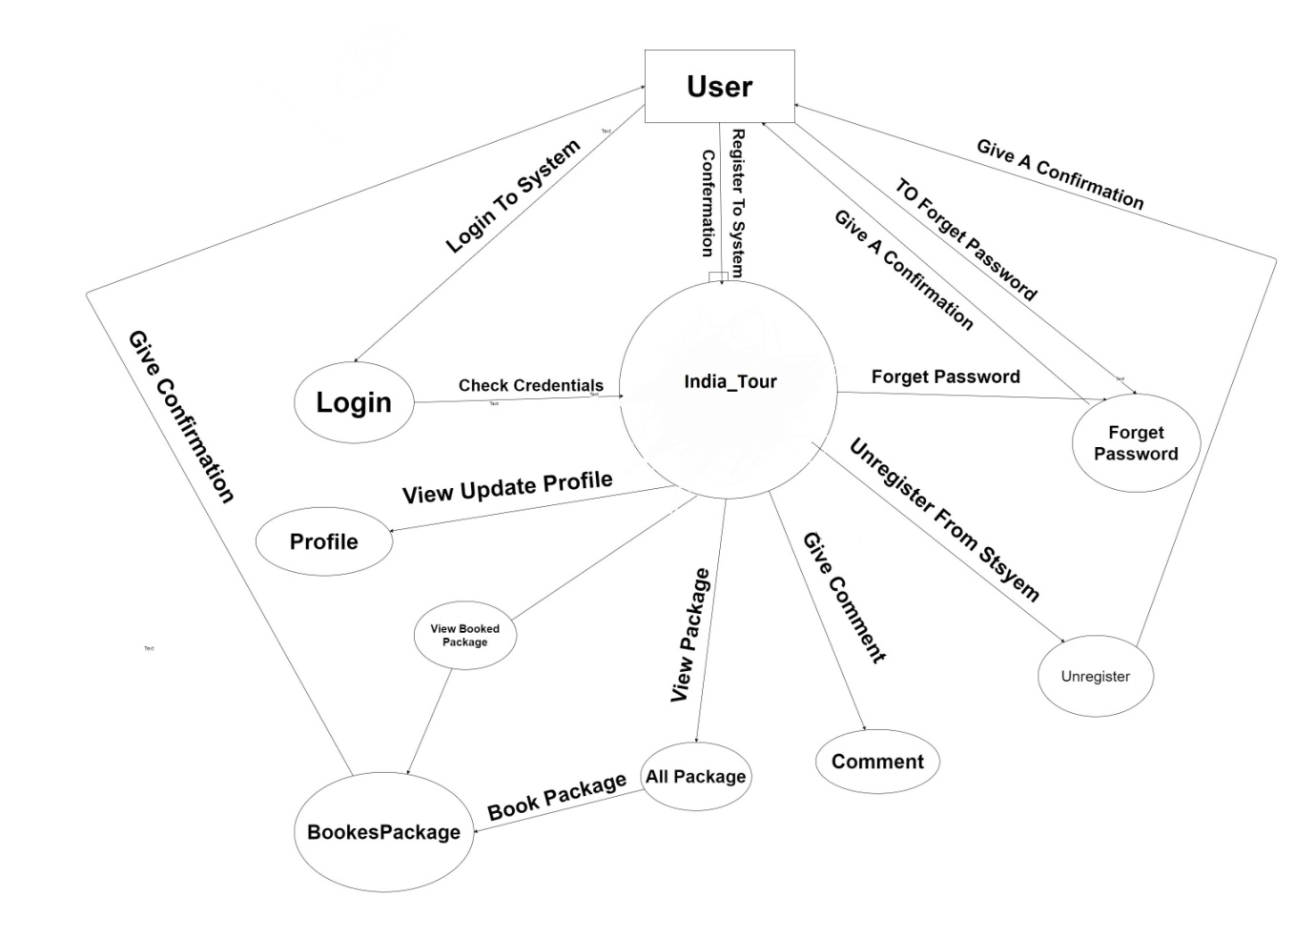

* **Admin Module DFD**

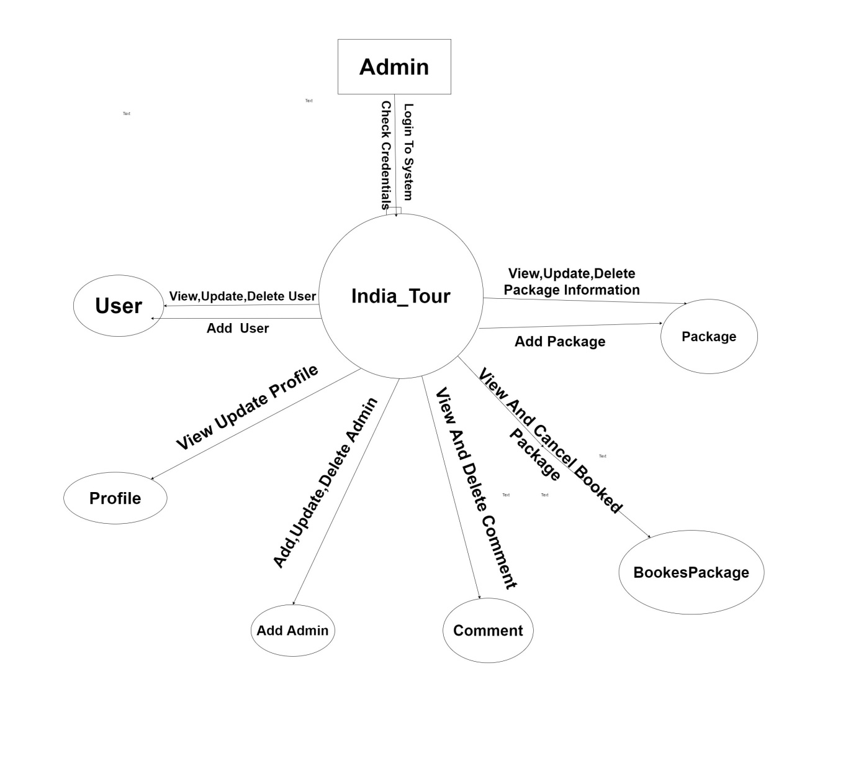

**4.2 E-R Diagram:**

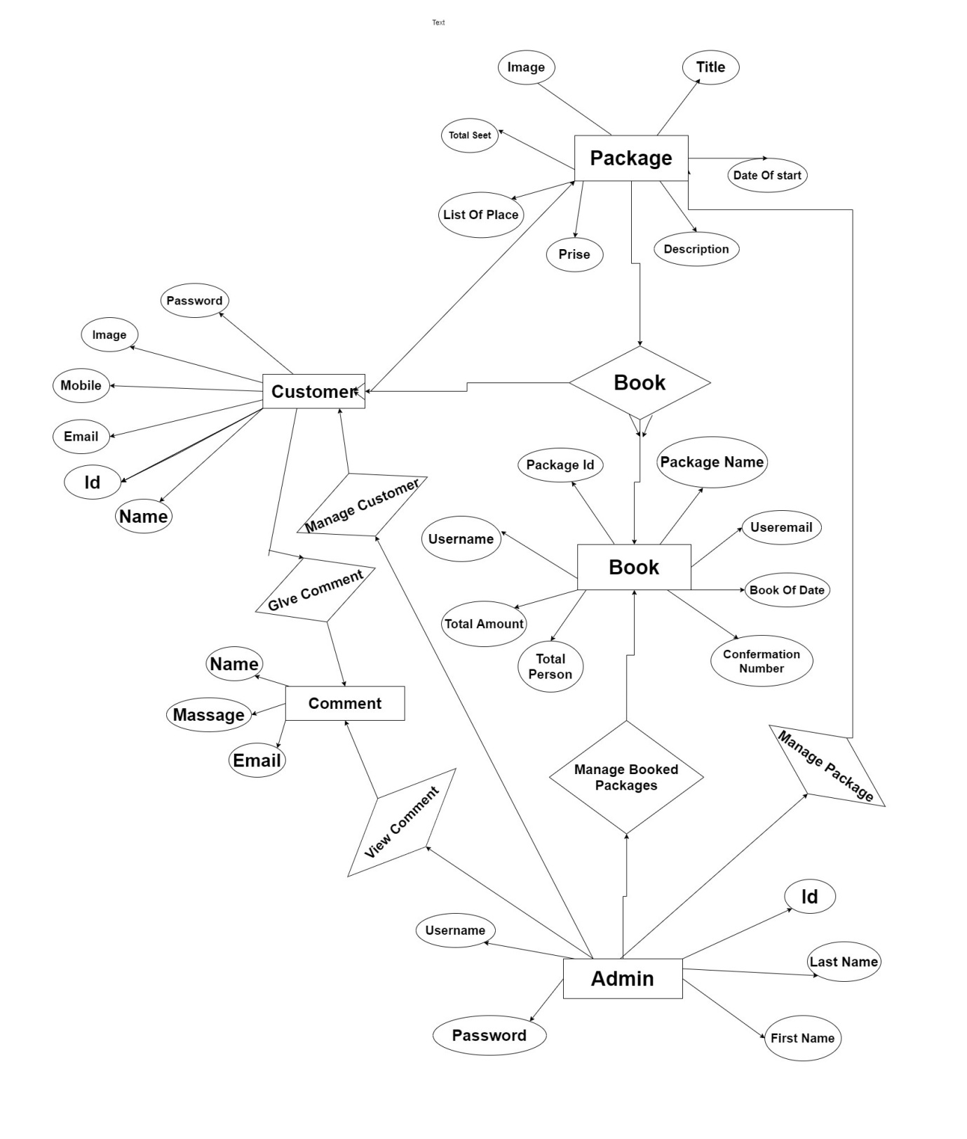

**4.3 Class Diagram**

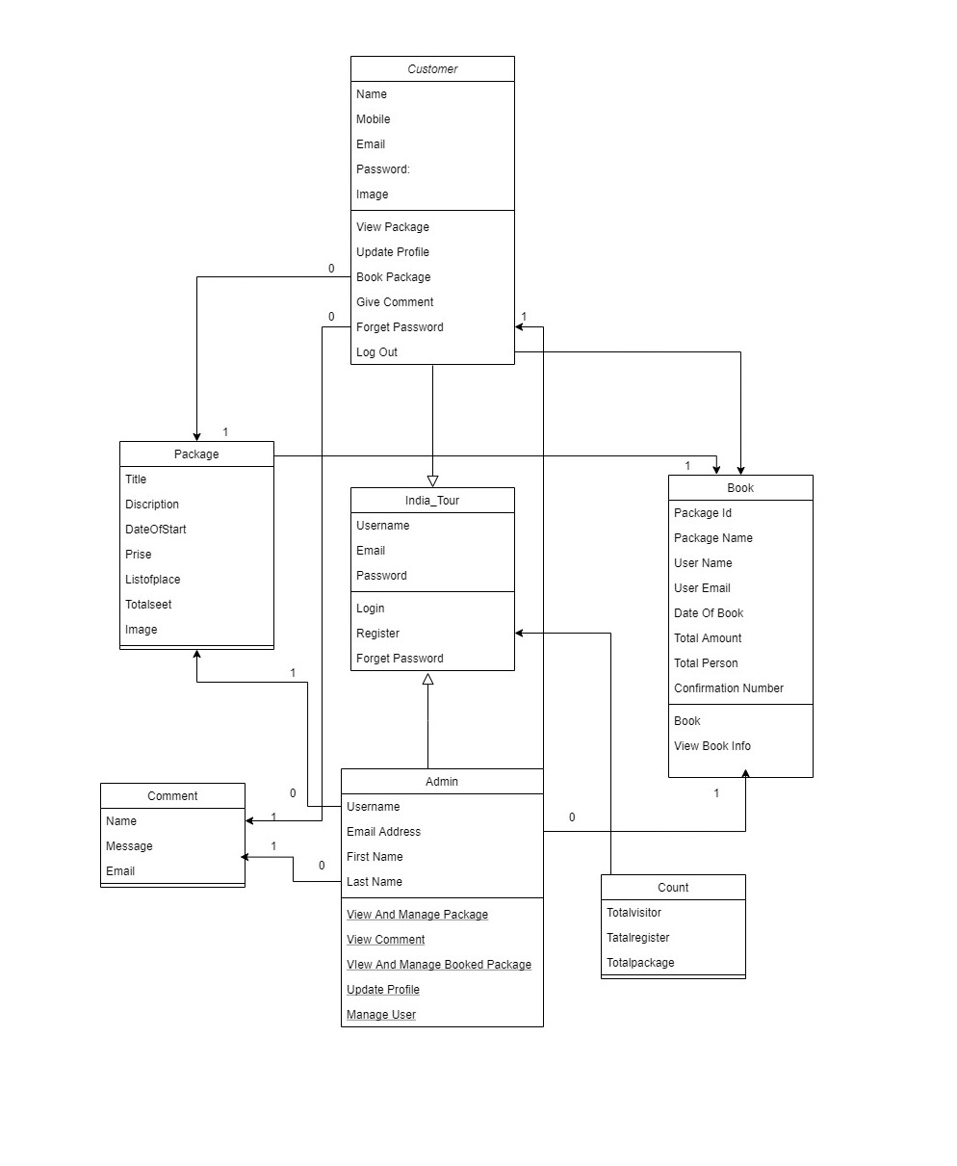

**4.4 Use Case Diagram**

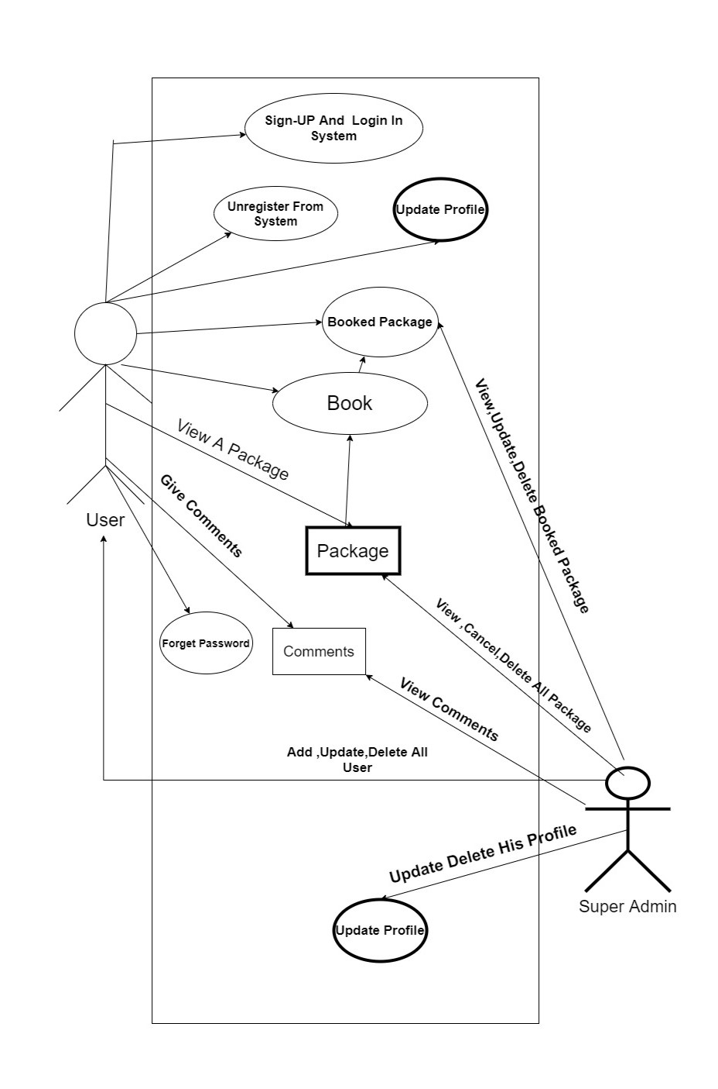

**4.5 Sequence Diagram**

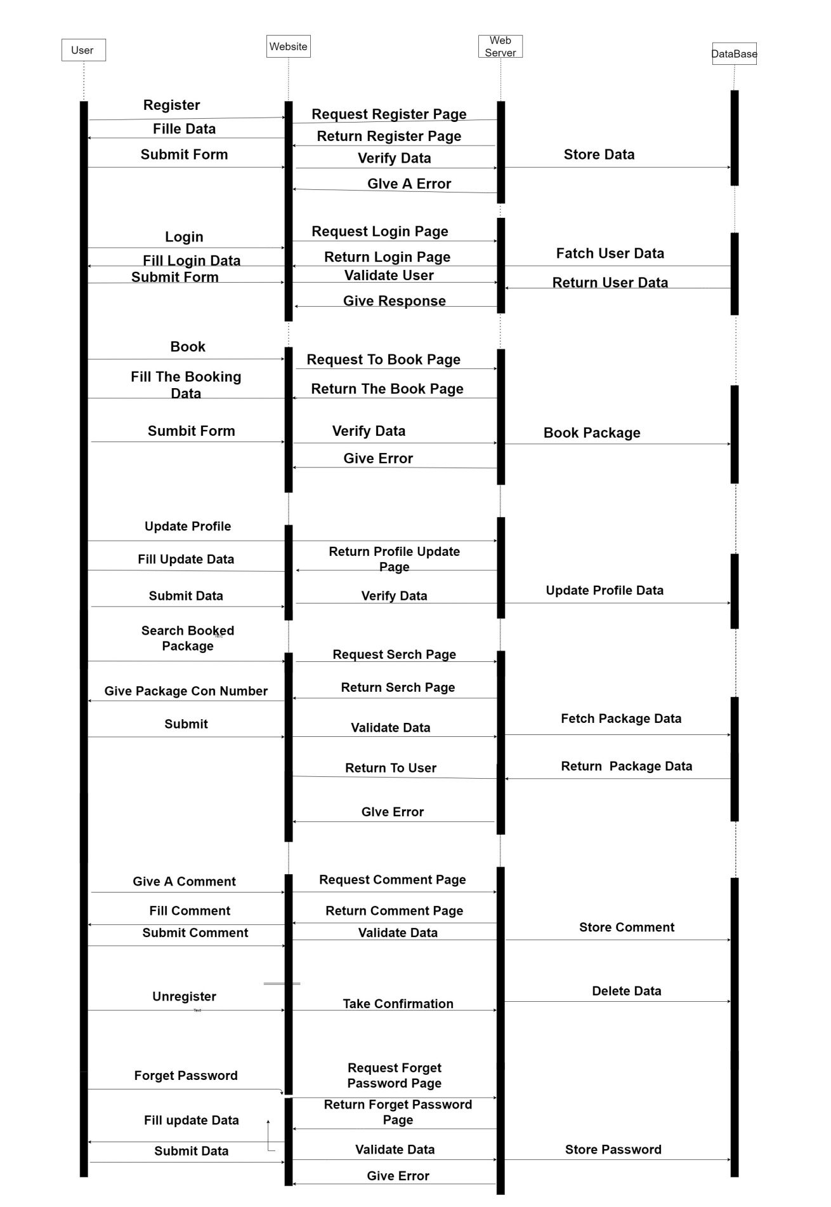

**4.6 Activity Diagram**

* **User Activity Diagram**

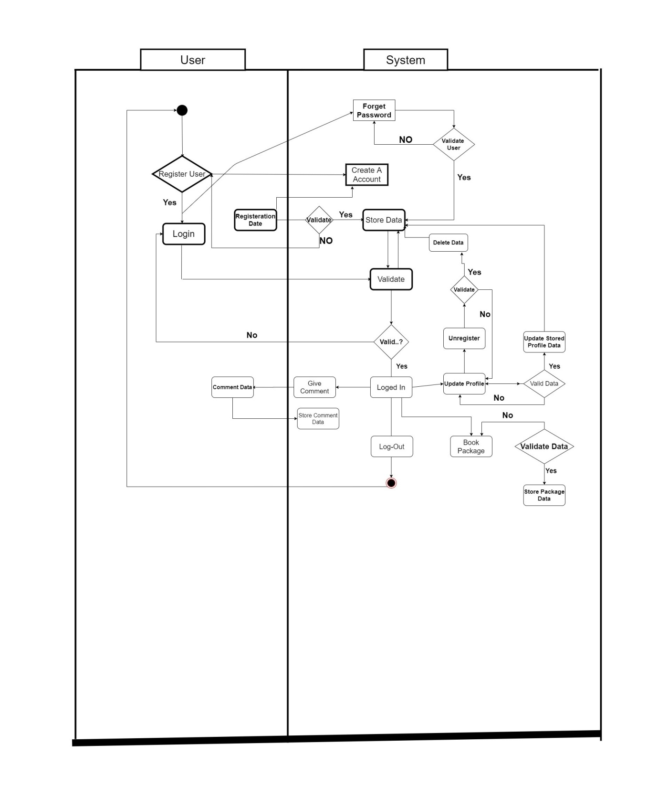

* **Admin Activity Diagram**

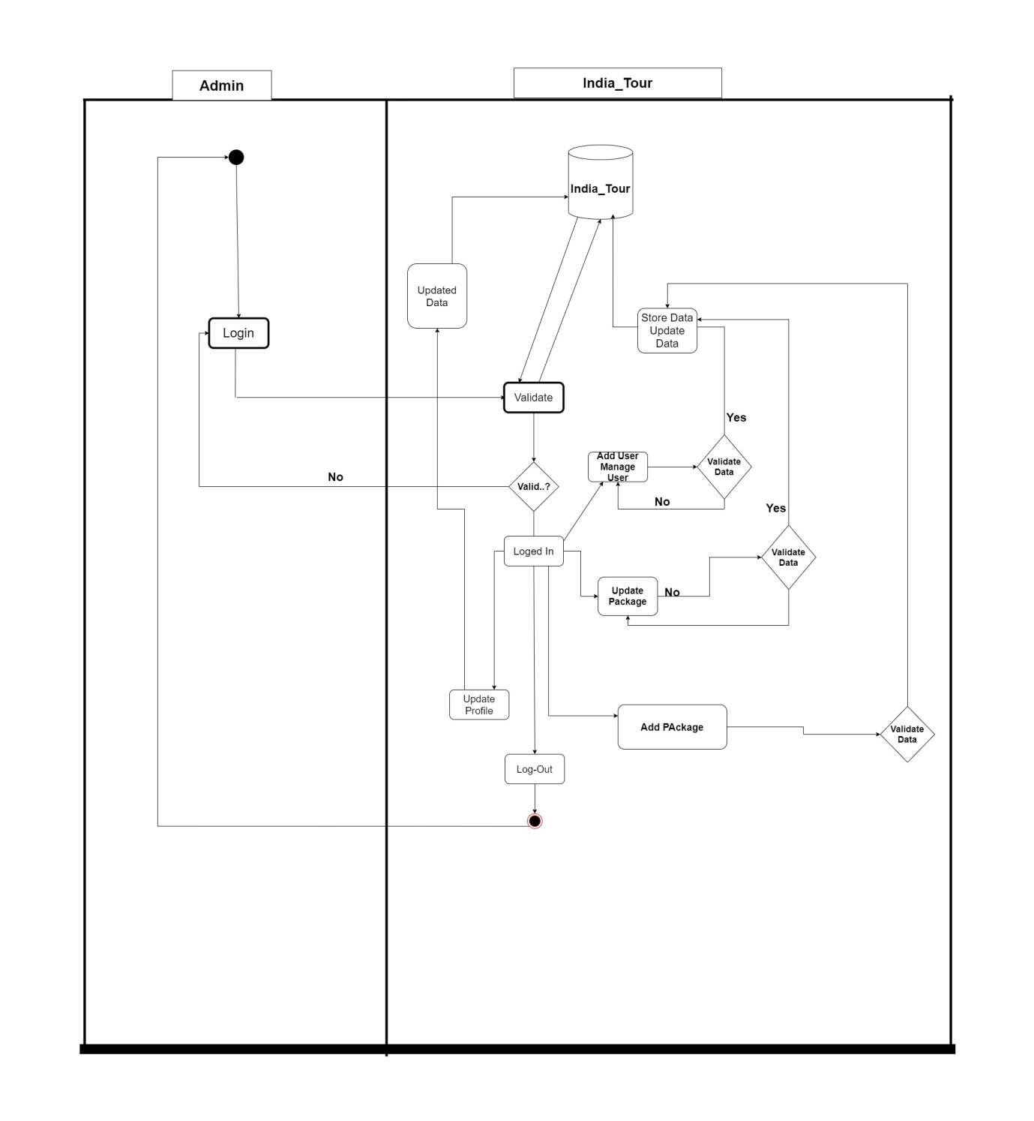

**4.7 Data Dictionary (Database)**

* **Customer:**

|  |  |  |  |
| --- | --- | --- | --- |
| No | Name | Type | Constrain |
| 1 | ID | Integer(100) | Not Null  Auto Increment |
| 2 | Name | Varchar(255) | - |
| 3 | Email | Varchar(225) | - |
| 4 | Mobile | Varchar(225) | - |
| 5 | Image | Varchar(255) | - |

* **Users:**

|  |  |  |  |
| --- | --- | --- | --- |
| No | Name | Type | Constrain |
| 1 | ID | Integer(50) | Not Null  Auto Increment |
| 2 | Username | Varchar (225) | - |
| 3 | Password | Varchar(255) | - |
| 4 | Email Address | Varchar(225) | - |
| 5 | First Name | Varchar(225) | - |
| 6 | Last Name | Varchar(20) | - |

* **Contact :**

|  |  |  |  |
| --- | --- | --- | --- |
| No | Name | Type | Constrain |
| 1 | Full Name | Varchar(50) | - |
| 2 | Email | Varchar(50) | - |
| 3 | Massage | Varchar(350) |  |

* **Package:**

|  |  |  |  |
| --- | --- | --- | --- |
| No | Name | Type | Not null |
| 1 | Id | Integer(255) | Not Null  Auto increment |
| 2 | Title | Varchar(255) | - |
| 3 | Description | Varchar (225) | - |
| 4 | Date Of Start | Varchar(255) | - |
| 5 | Prise | Varchar(255) |  |
| 6 | List Of Place | Varchar(255) | - |
| 7 | Total Seet | Varchar(225) |  |
| 8 | Image | Image(225) |  |

* **Book :**

|  |  |  |  |
| --- | --- | --- | --- |
| No | Name | Type | Constrain |
| 1 | Id | Integer (100) | Not Null  Auto Increment |
| 2 | PackageId | Varchar(225) | - |
| 3 | Package Name | Varchar(225) | - |
| 4 | User Name | Varchar (225) | - |
| 5 | User Email | Varchar (225) | - |
| 6 | Date Of Book | Date | - |
| 7 | Total Amount | Varchar (225) | - |
| 8 | Total Person | Varchar(225) | - |
| 9 | Confirmation Number | Varchar (225) | - |

* **Count:**

|  |  |  |  |
| --- | --- | --- | --- |
| No | Name | Type | Constrain |
| 1 | ID | Integer  (50) | Not Null  Auto Increment |
| 2 | Total Visitor | Varchar(225) | - |
| 3 | Total Regiaster | Varchar(225) | - |
| 4 | Total Package | Varchar(225) | - |

5

**Screen Design**

**5.1 Input Screen**

**5.2 Screen Layout**

**5.3 Sample Code**

**5.1 Input Screen / 5.2 Screen Layout**

* **Index Page.**

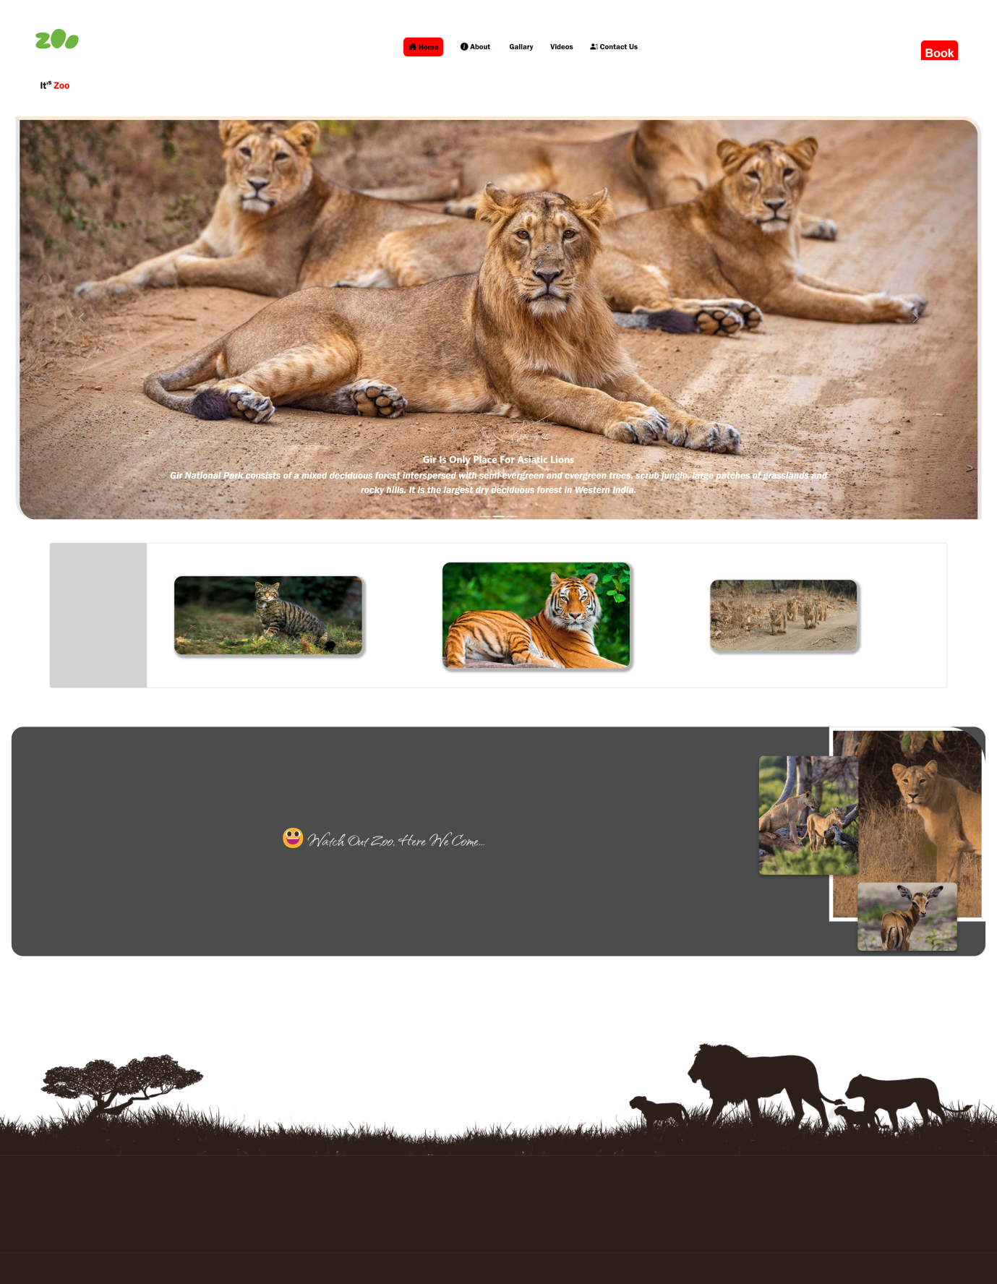

* **User Log In/sign-in:**

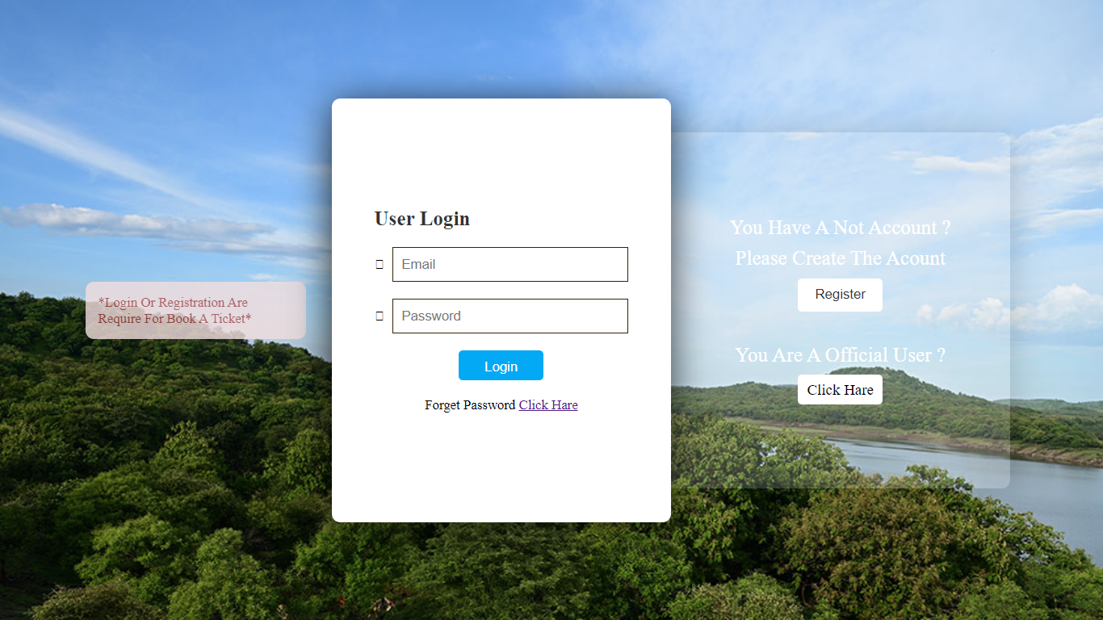

* **User Registration/Sign-up:**

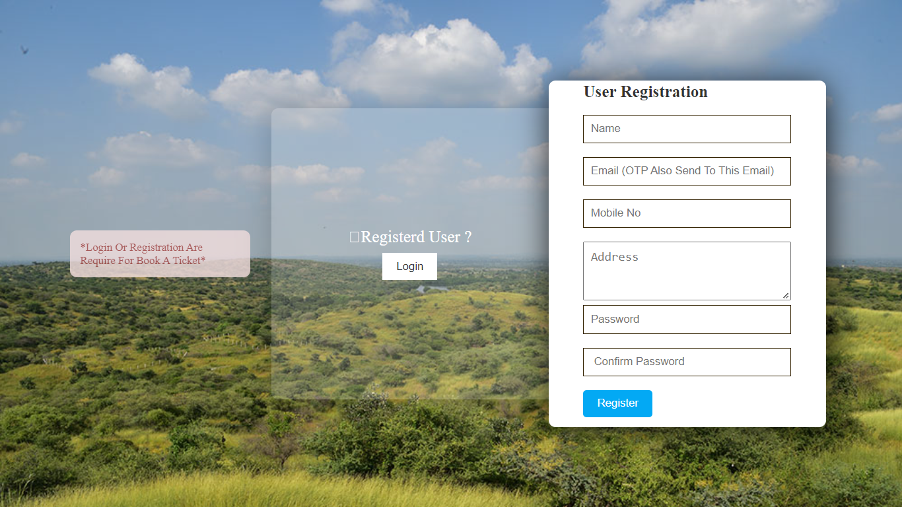

## Admin Login:

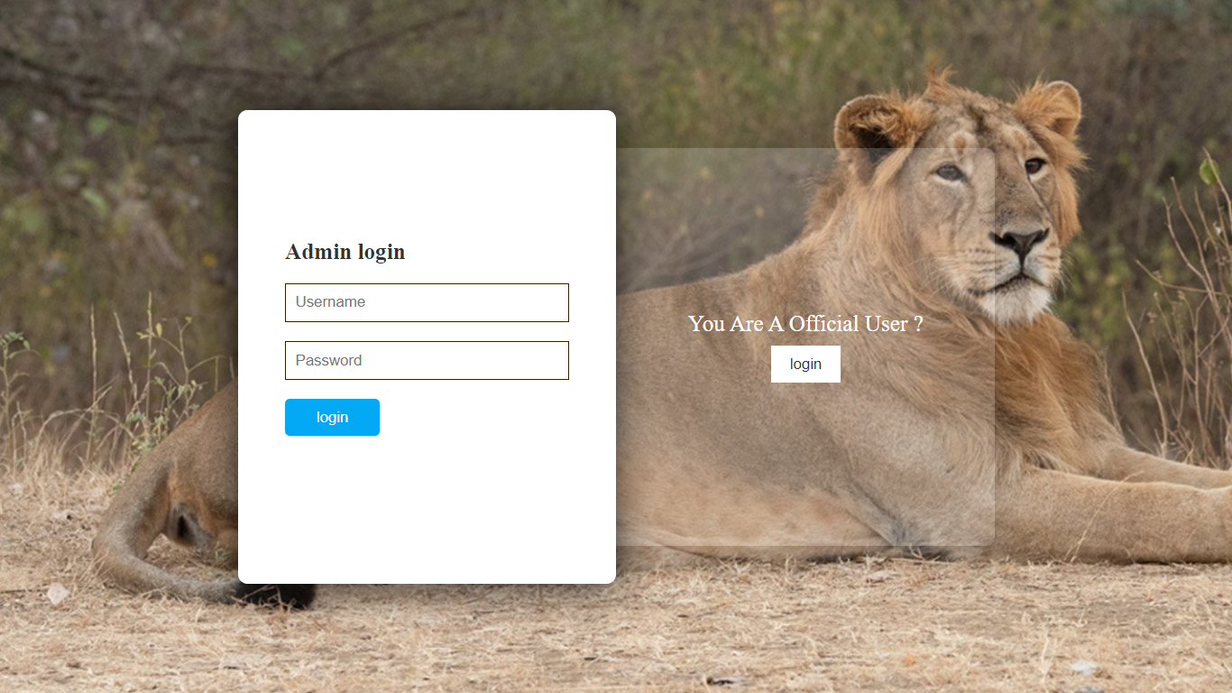

## Staff-Login:

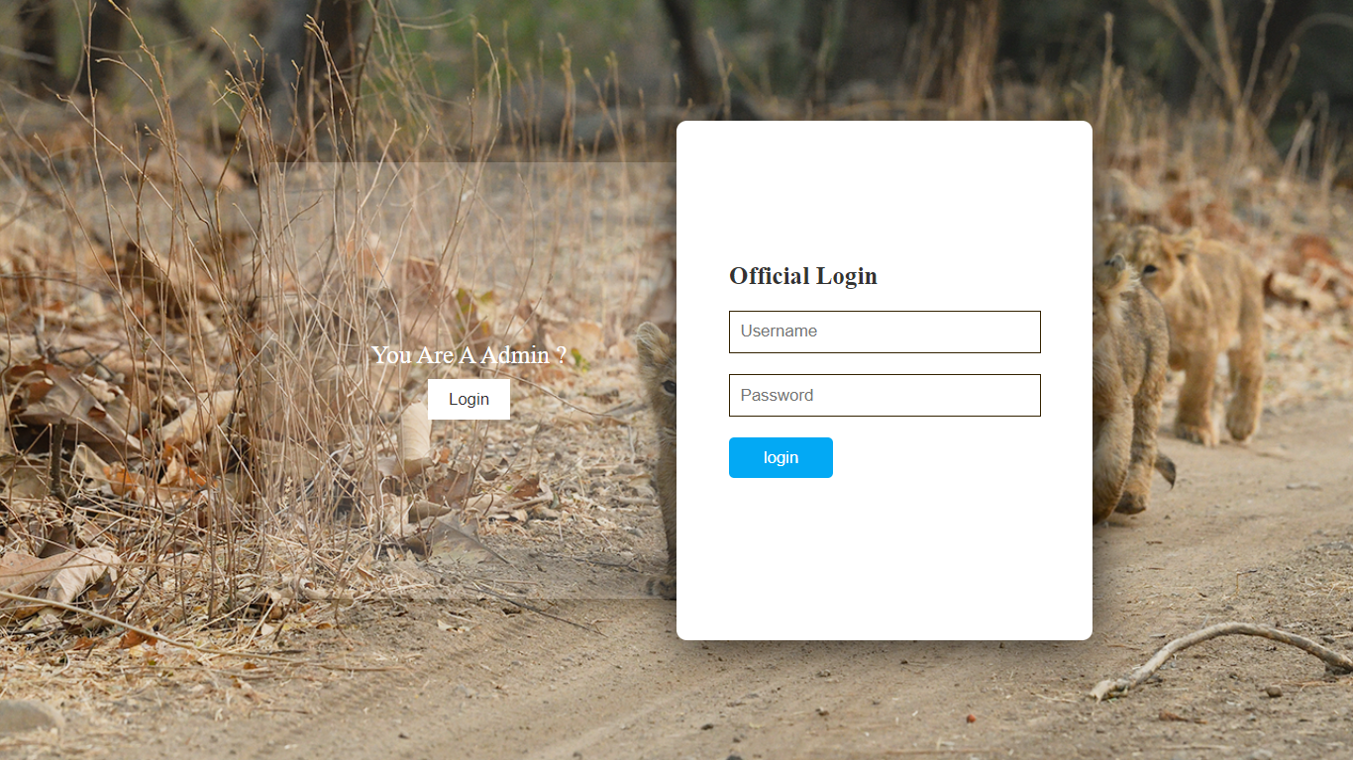

* + - **Admin Dashboard:**

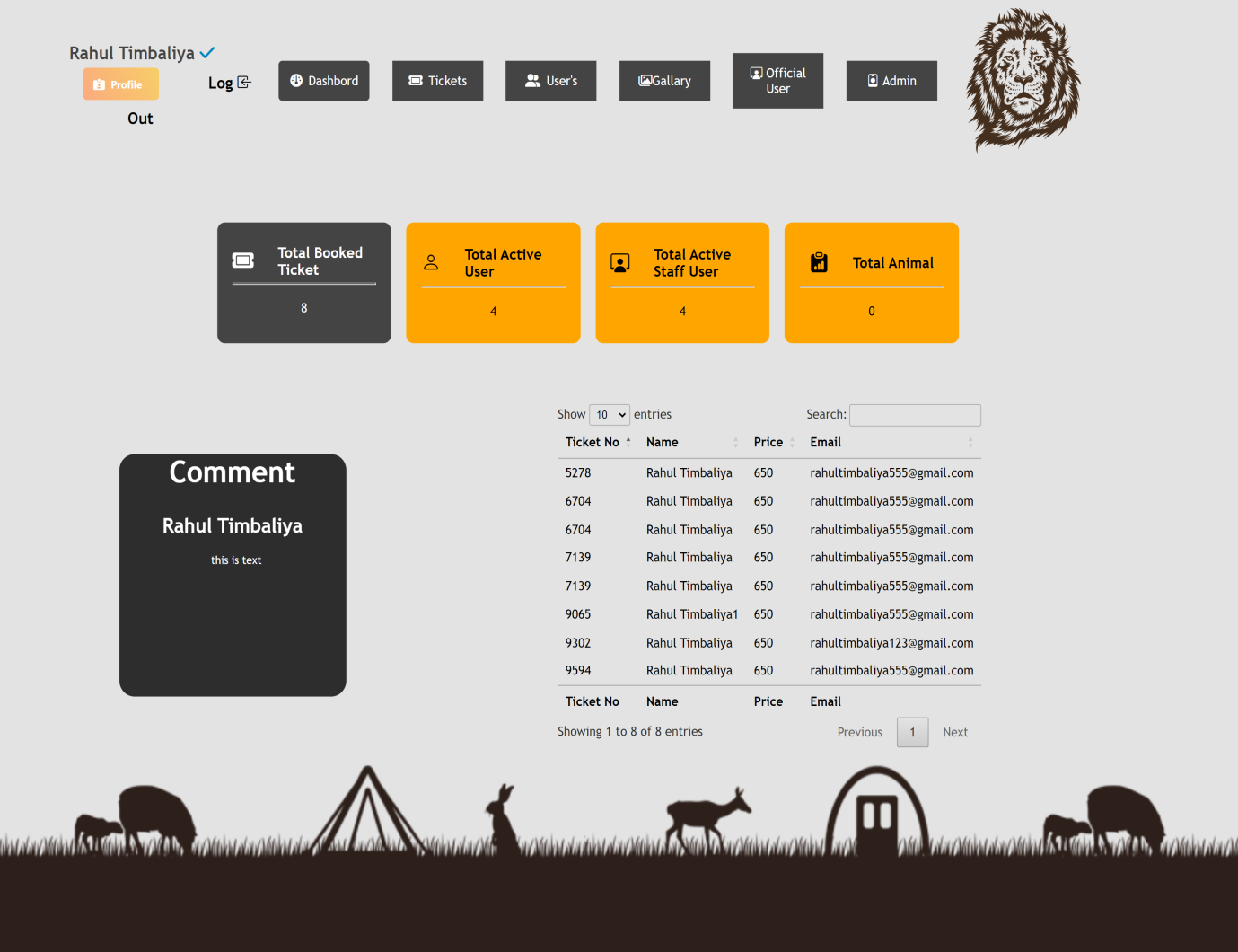

* + - **Gallary:**

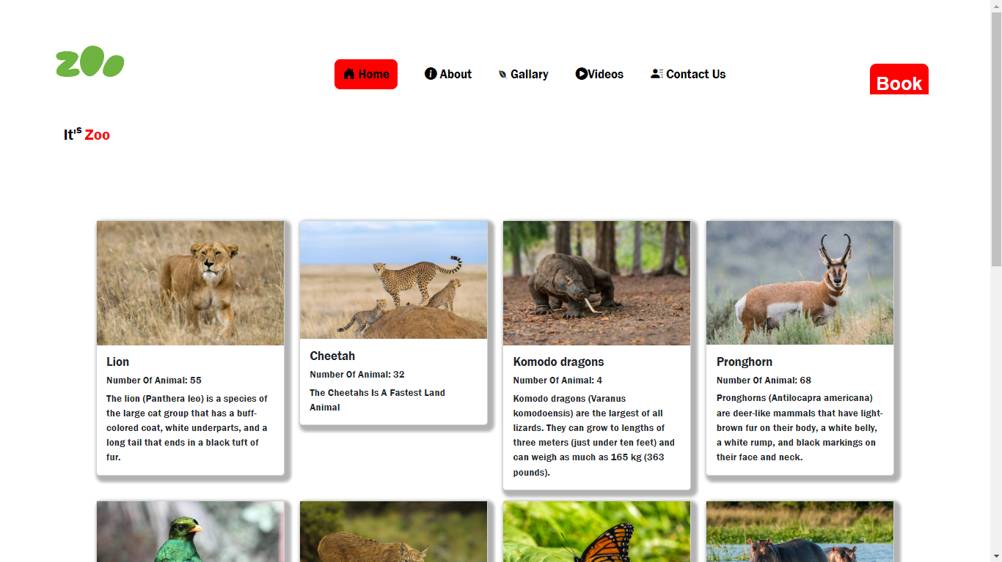

## Videos:

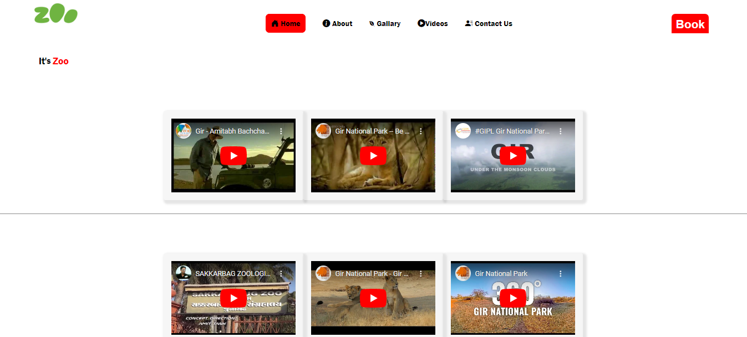

## About- Us:

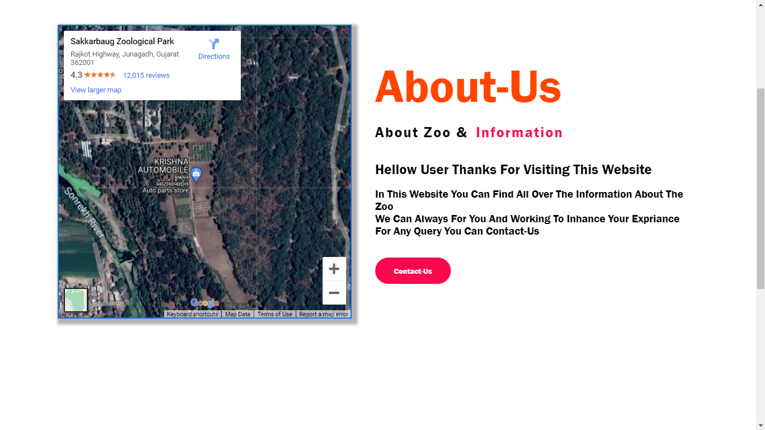

## Contact Us:

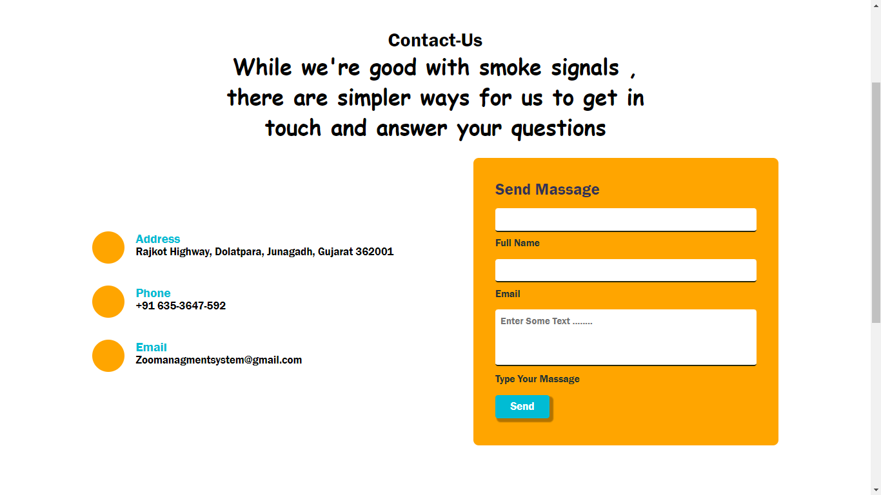

## User-Forgot Password:

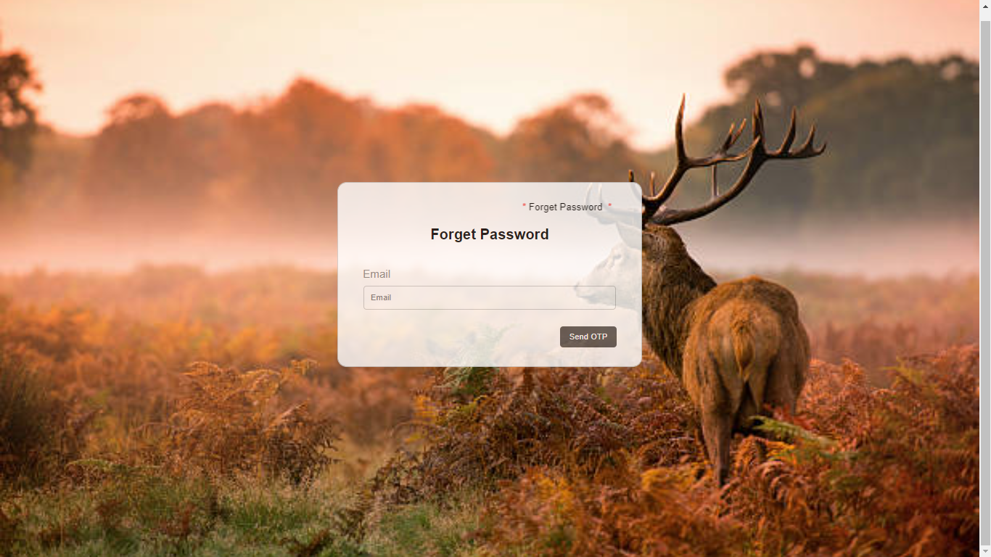

## User-Profile Page:

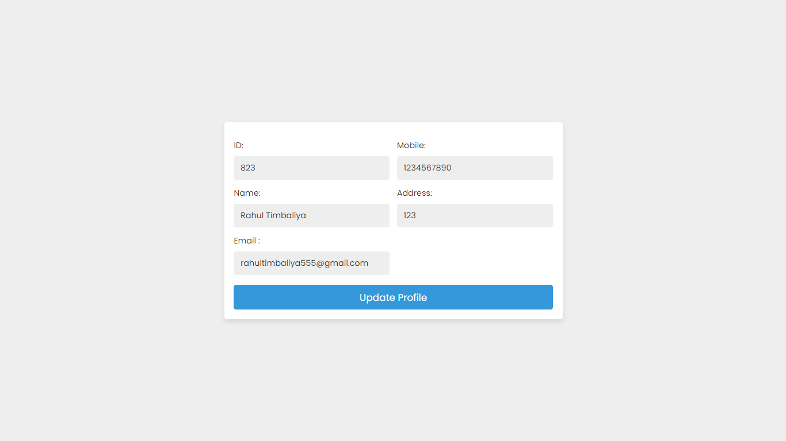

## S

## Staff-User-Page 1:

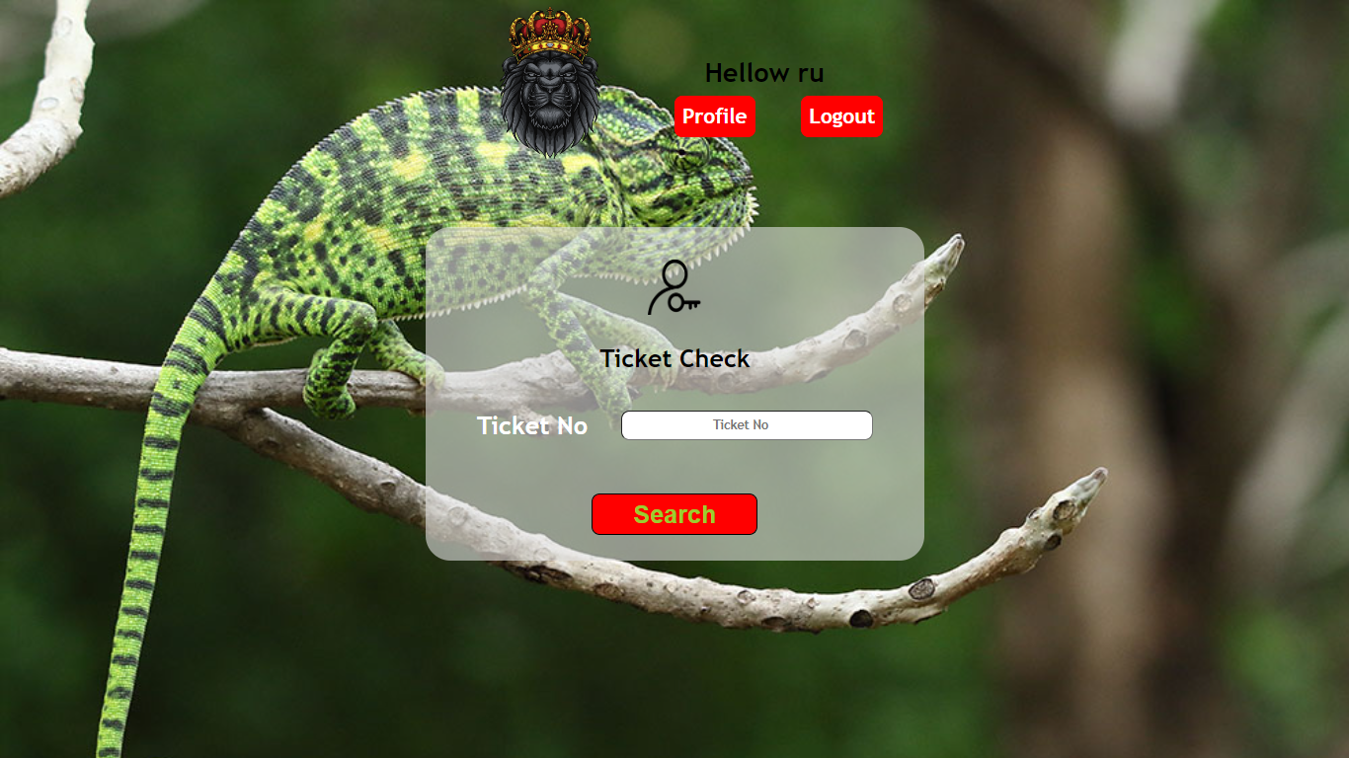

## Staff-User-Page 2:

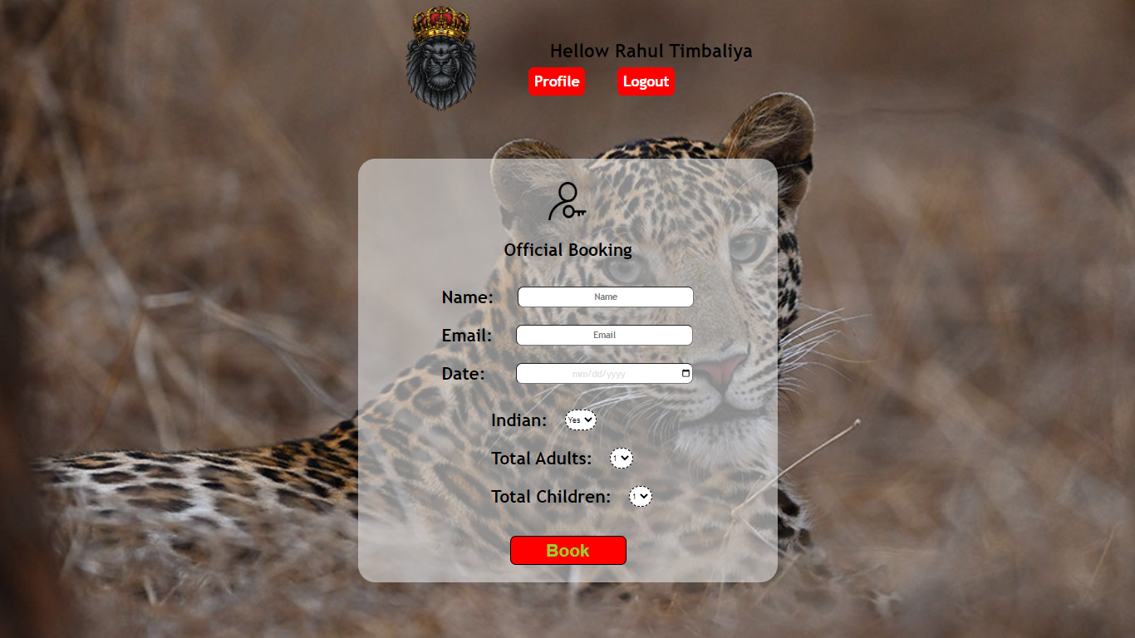

## Staff-User Profile:

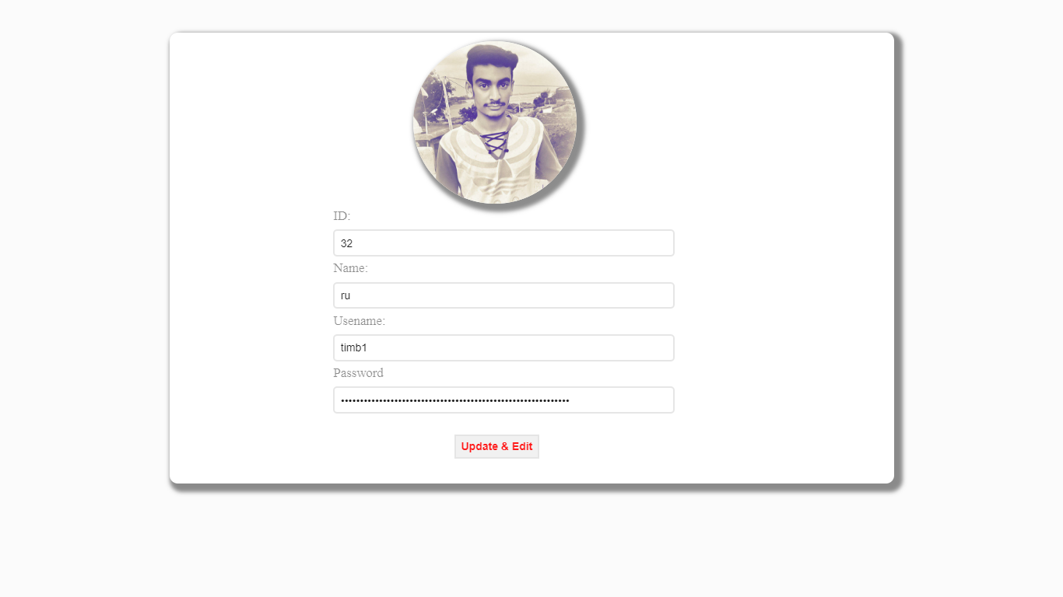

## Developer Info Page:

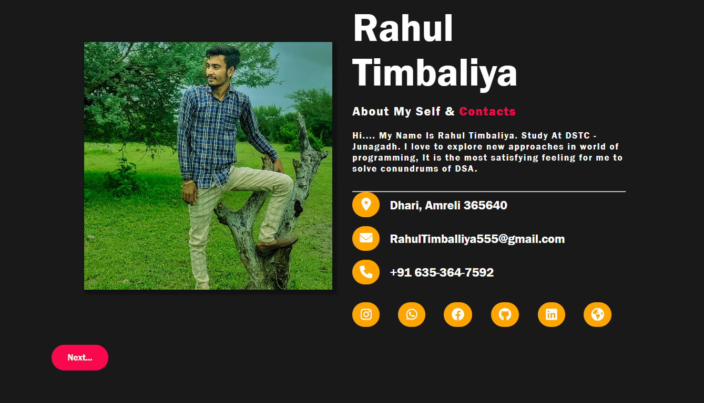

## Admin Section:

## Admin-Profile:

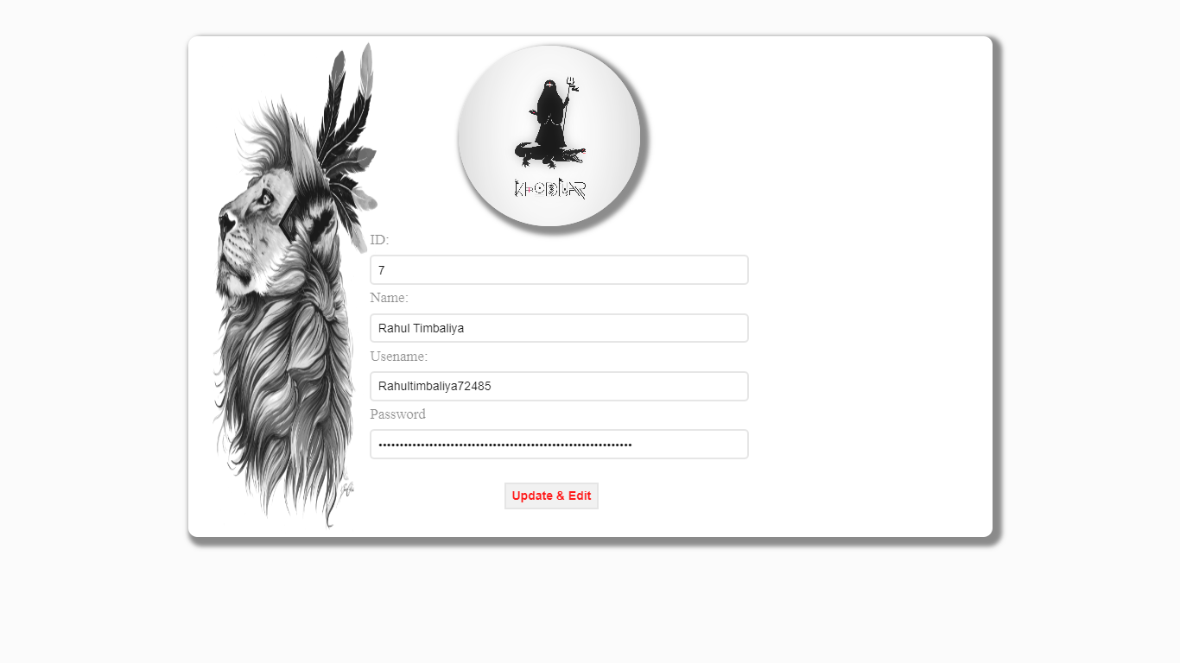

## View Ticket:

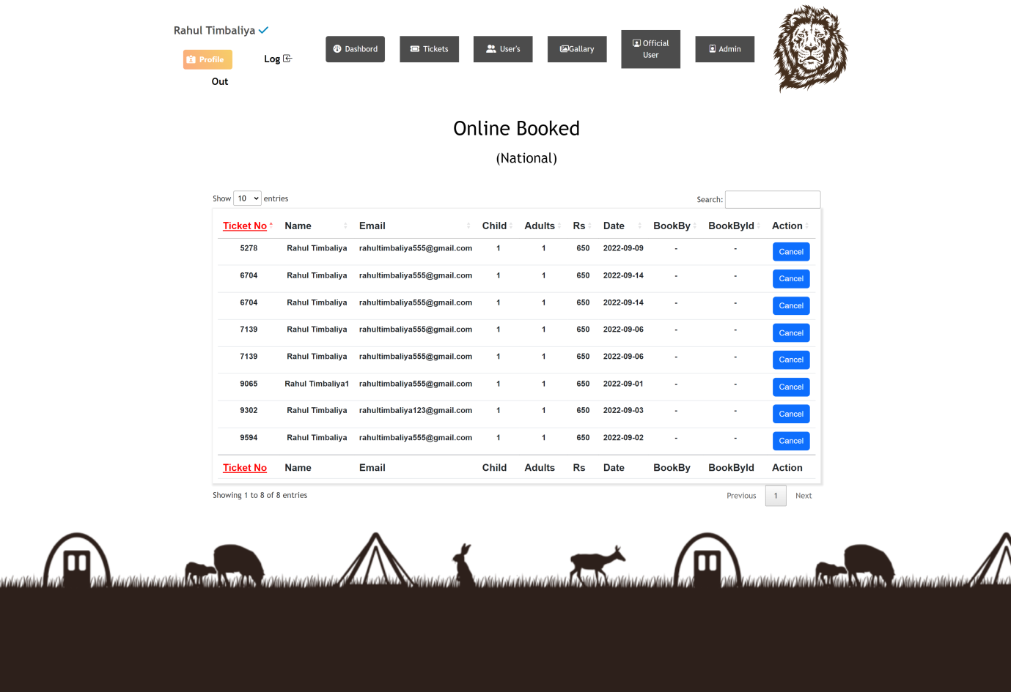

## Edit-Price:

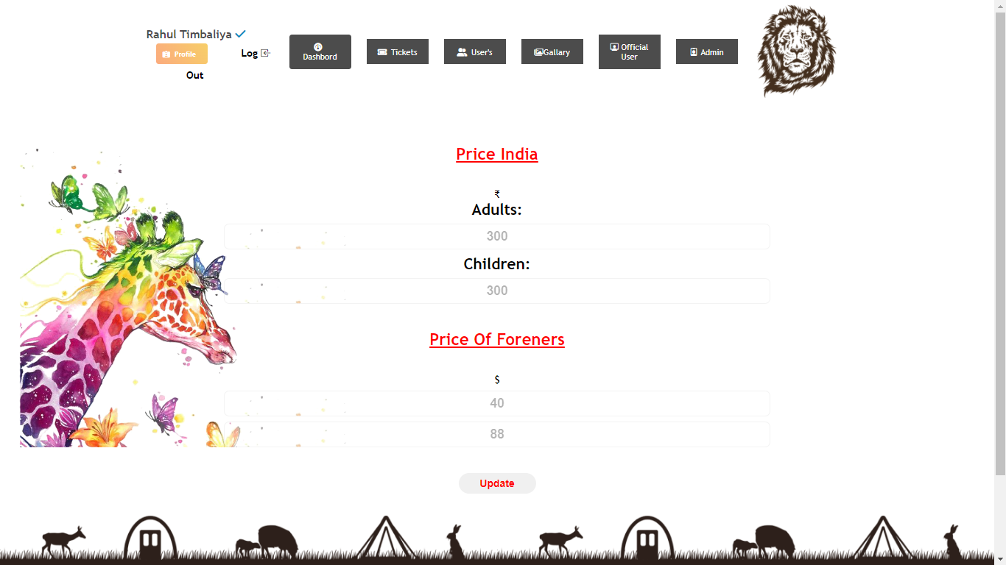

* Add-User:

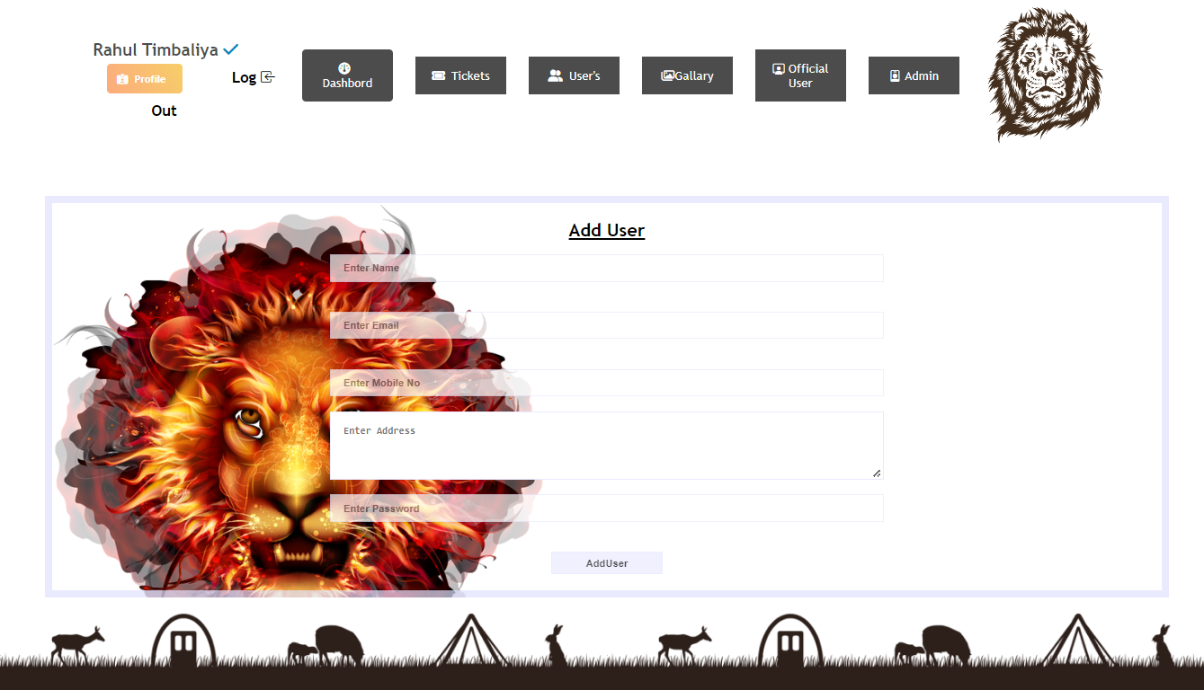

* View-Registerd User:

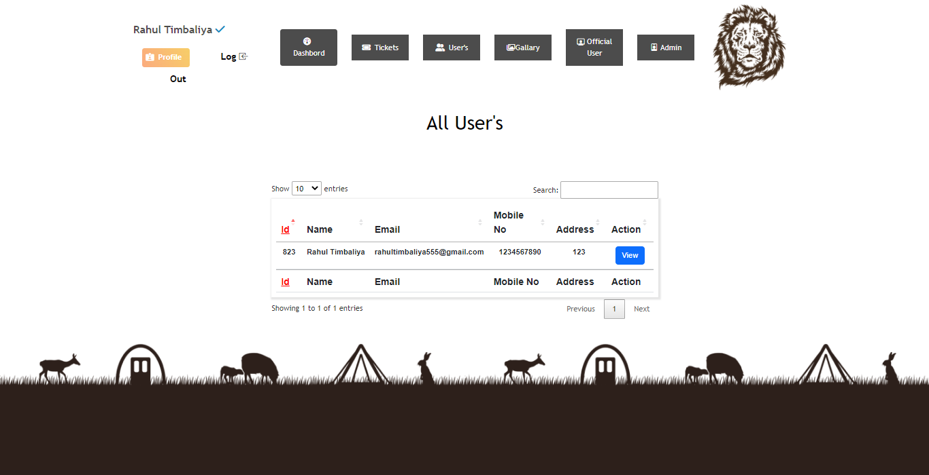

* Add Animal Info:

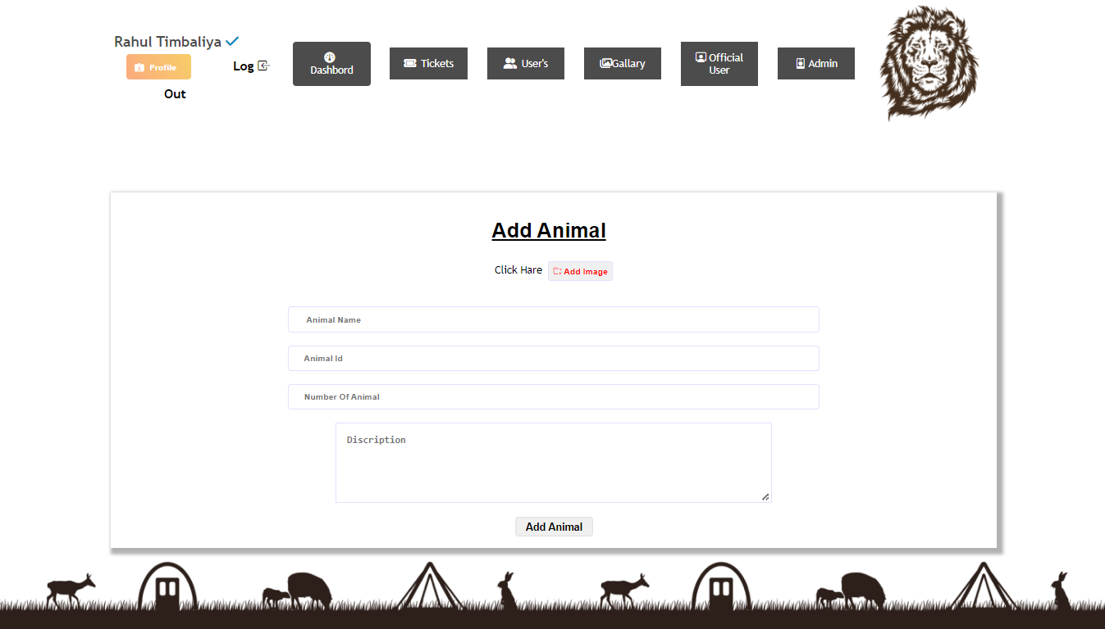

* View Animal Info:

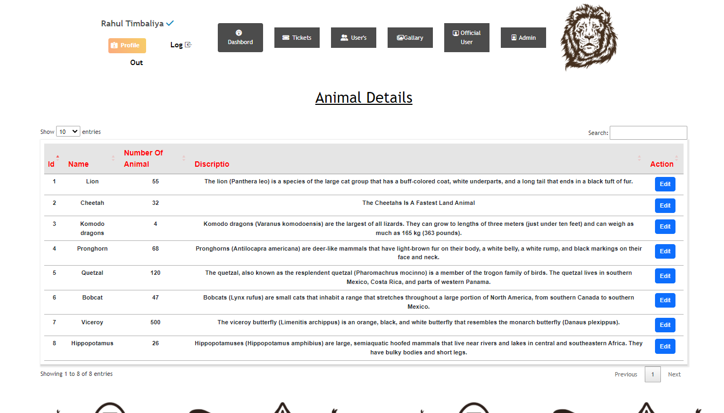

* Add Staff User:

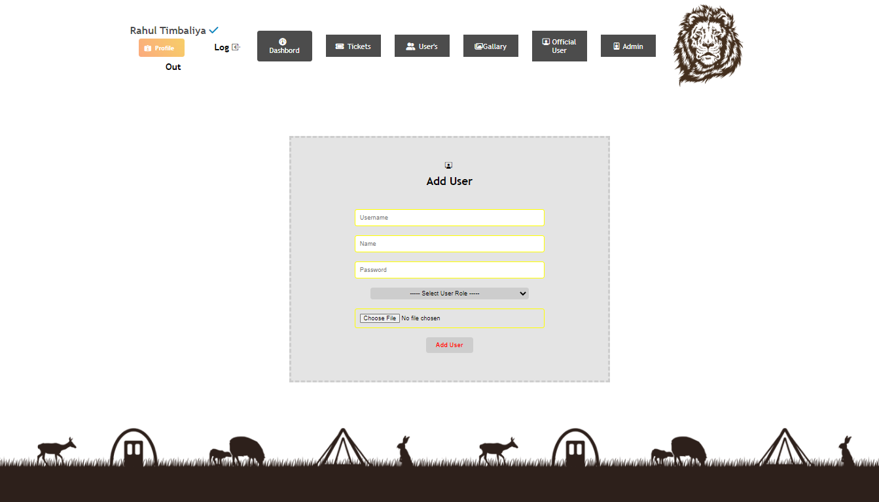

* Add Staff User:

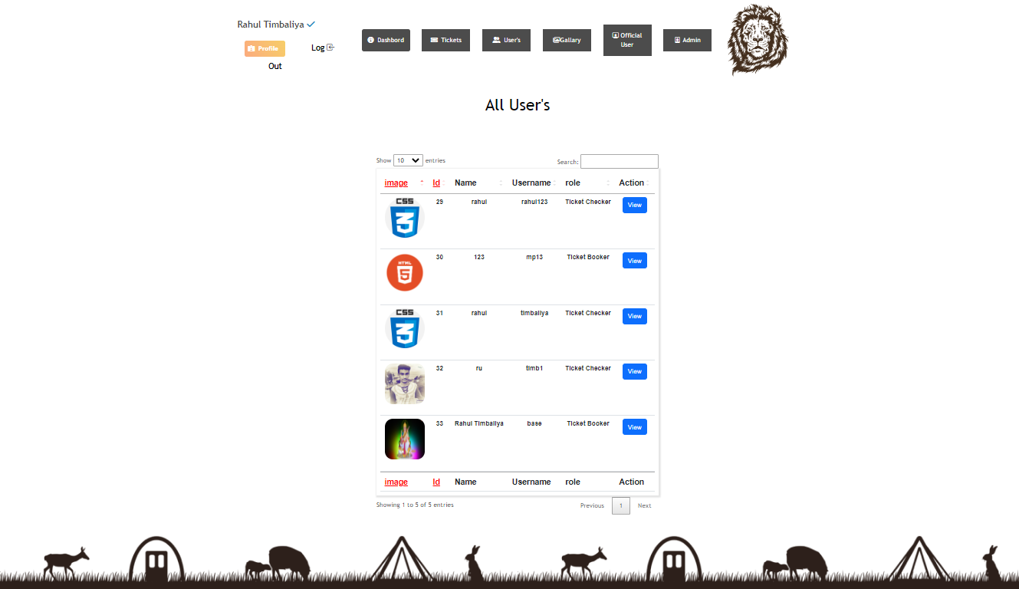

* Add Staff User:

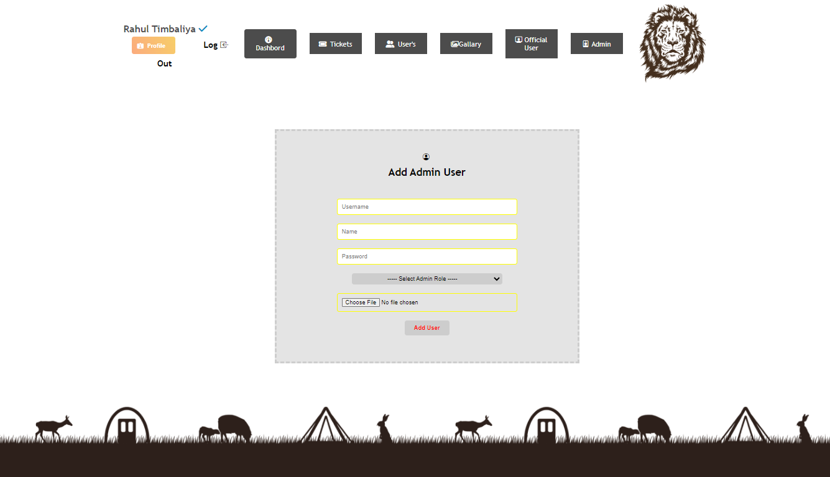

* Add Staff User:

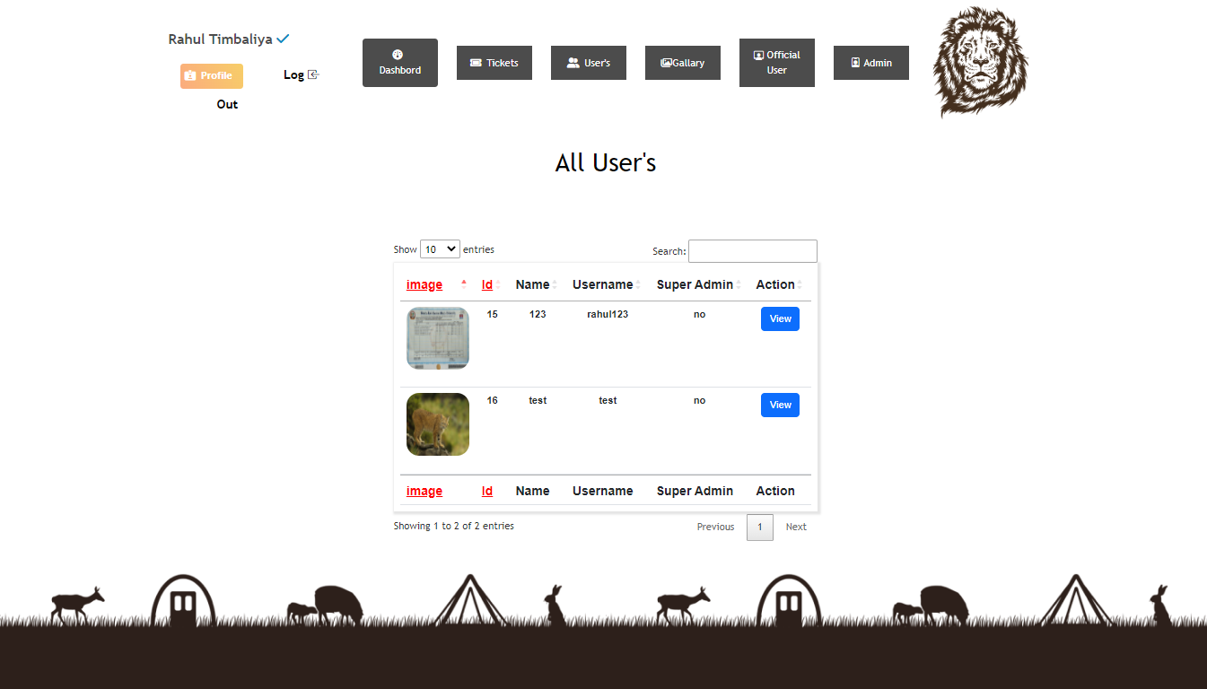

6

**Coding**

7

**Testing**

**(Manual,Test Case And Test dAta)**

**7.1 Manual Testing**

**7.2 Test Case**

**Testing**

Testing is the process of evaluating a system or application, to check whether the application meets all requirements of the client and to detect the errors.

Generally testing can be classified into static testing and dynamic testing.

Again Dynamic Testing is classified into two types: Structural Testing (or) white box, Functional Testing (or) Black Box testing.

**Static Testing**

Verification activities fall into the category of Static Testing. Static testing refers to testing something that’s not running. It is examining and reviewing it. i.e., to check whether the work done meets the standards of the organization. Reviews, Inspections and Walk-through are static testing methodologies.

Example: The specification is a document and not an executing program. When we read it to find out the issues, it is considered as static testing.

**Dynamic Testing**

Dynamic Testing involves working with the software, giving input values and checking if the output is as expected. These are the Validation activities. Unit Tests, Integration Tests, System Tests and Acceptance Tests are few of the Dynamic Testing methodologies.

Techniques used are determined by type of testing that must be conducted.

* Functional ("black box") testing.
* Structural (usually called "white box") testing.

Black box testing involves looking at the specifications and does not require examining the code of a program. Tests that examine the observable behavior of software as evidenced by its outputs without referencing to internal functions is black box testing. It is not based on any knowledge of internal design or code and tests are based on requirements and functionality. Nowadays there are automatic code generation tools and code re-use becomes more prevalent, analysis of source code itself becomes less important and functional tests become more important.

Black box testing is easy as it is based on system’s response for a given user’s input. If we know the business functionality of the product, we can do black box testing. On the other hand, white box testing requires programming knowledge to know the internals of the code. Also it is time consuming. So only a developer can become a white box tester\

**Black-Box** tests are used to demonstrate that:

* Software functions are operational.
* Input is properly accepted.
* Output is correctly produced.
* Integrity of external information (database) is maintained.

**White-Box** tests can be designed only after a component-level design (or source code) exists. The logical details of the program must be available. The status of the program is examined at various points to determine if the expected status corresponds with the actual status.

Internal program logic is tested using ‘White Box’ test case design techniques.

Using White-Box testing methods we can derive test cases that:

* Guarantee that all independent paths within a module have been exercised at least once.
* Execute all loops at their boundaries and within their operational bounds.
* Exercise internal data structures to ensure their validity.

6

**Limitations and Future**

**Enhancement**

* **Limitation :**
* Online payment is not available.
* Mandatory sign-up needed for the Ticket Book. But User Can Visit The Site With Out Sign-in Or Sign-Up.
* Only read module for viewer.
* Different rights for actors.
* **Future Enhancement :**
* Payment method will be available.
* New customization in website.
* Add New Services
* Some UI Changes
* More modules will be updated.
* Bug fixes and performance.
* More attractive.

7

Bibliography

* **Book Used :**
* Software Engineering – R.S.Pressman
* **Reference Sites:**

<https://www.tutorialspoint.com/php/>

https://www. stackoverflow.com/

https://www. getbootstrap.com/

[htttp://www.youtube.com](http://www.youtube.com)/

[htttp://www.jquery.com](http://www.youtube.com)/